THE IRISH TERRIER
One Breeder’s Perspective

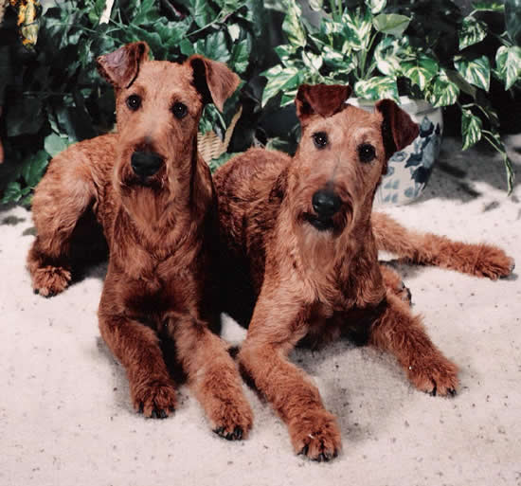

People With Their Companions
Rose Marie Saporito,

Rose Marie Saporito, breeder of the Irish Rose line of Irish Terriers, lives in a small town in Chester County, Pennsylvania, which is located northwest of Philadelphia.

Rose Marie has been breeding and showing Irish for about 35 years. She has been a member of the ITCA board of governors, Judges' Education Chairperson, Trophy Librarian and has held other executive positions in both the ITCA and the Irish Terrier Club of New York. She has been a member of the ITCA, ITCNY, the Irish Terrier Club of S. California and the Irish Terrier Association of England.

Rose Marie has bred and raised over 40 litters of puppies. The prefixes of Irish Rose, Sarsfield, Ballycallar and in combination with others have produced over 40 champions. To continually improve her line she has expanded her pedigrees to include dogs from Rockledge, Cocksure, Aran Isles, and from Swedish (Merrymac) and English bloodlines. The dogs are breed for temperament and type, overall soundness and health to provide a foundation for great companions or show dogs.

Front cover:
Victor: Irish Rose Sarsfield Starman
Lucy: Ch. Irish Rose Sarsfield Shoo'n Star

©2012 Rose Marie Saporito
People With Their Companions

It is our understanding that material in this volume
is either original or in the public domain.
I.C. MacDonald, editor

IN MEMORY
Helen Best
David Brown
Bob Clyde
Alan Kufferman
Judy Labash
Mary O’Brien
Mary Roberts
Marilyn Shaw
Minor Summers

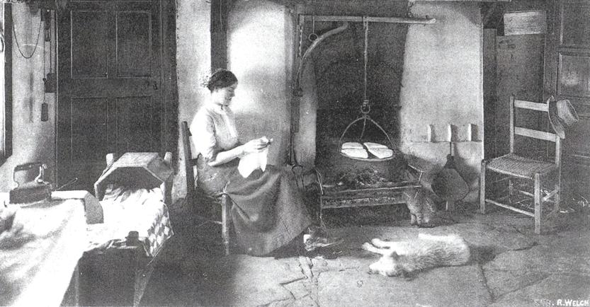

Many thanks to all those who have added to the completion of this handbook.

Mike Kowalczk, Bob Clyde, Elizabeth Budzilowicz, Linda Honey, Jessica Nash,
Chris Accurso, Jill Brown, Thea Lahti, Pat Schlegel, Debbie Constant,
Kelly Hair, Maureen Moskowicz, Doug Raport, Bobby Wynne, Joan Herschaft,
Pat MacDonald, Ian MacDonald.

Purpose
Although the breed standard is fairly similar throughout the world, it is subject to a degree of interpretation, and each breeder will have a personal opinion on breeding, raising, and training Irish Terriers, preparing them for the ring and assessing the final product. This handbook is intended to provide new and experienced owners alike with helpful information about the Irish Terrier. It’s one person’s perspective but incorporates ideas from other sources and is meant to be a quick reference tool that you can use to answer basic questions of care and maintenance.
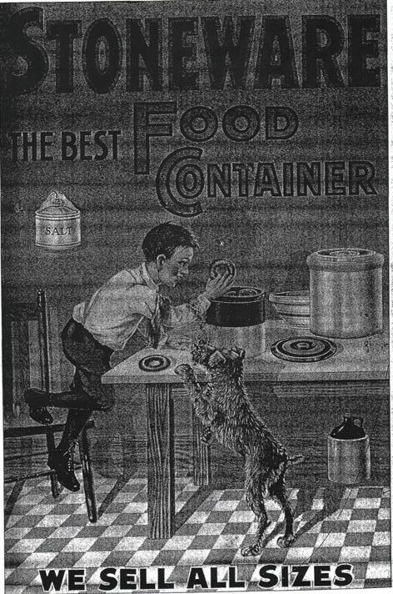
In the first section the reader is taken through a review of breed type and structure using the breed standard as a starting point. Next there is a section on maintenance that includes ear setting, grooming and routine care. The third section focuses on basic dog behavior and contains important guidelines for handling the challenges of puppy hood.

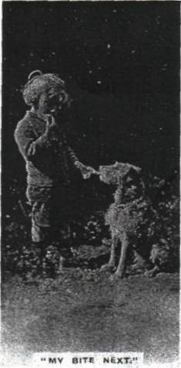

Throughout this book you will find diagrams, illustrations and quick tips for proper care. Important references are provided to help you find more information. As a special “Human” treat, we have assembled a collection of rarely seen depictions of the breed from early in its history to today. The Irish Terrier has a spirited and tenacious personality. Proper training is a must. The grooming requirements needed to maintain that “Mick” look take time and dedication to achieve. These facts can make owning an Irish a challenging experience. It is hoped that this book will be a useful resource to owners and provide positive results for a properly cared for and well behaved canine companion.

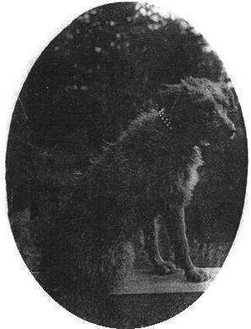
Contents
Purpose iii
I The Dog: What makes an Irish look like an Irish terrier 1
Correct and incorrect body outlines 2
Head and Ear Carriage 3
Coat and Types 5
Topline and Hindquarters 7
Stern or Tail 8
Feet 9
Teeth 9
II Basic Maintenance: How to make an Irish look like an Irish 10
Ear Training and Gluing 11
Variations on ear gluing 12
Grooming: Terms and Illustrations 16
Basic Stripping 18
Staged Stripping 19
Show Grooming 21
Pet Clippering 22
Care of Kinky Coat 24
Cracked Pads 25
Nails 25
Teeth 26
Anal Sacs 27
Stool Eating 28
III Dog Behavior: What makes an Irish act like an Irish 29
Basic Laws of Learning / Basic Laws of Training 29
Developmental Levels and Training 30
Crate Training 33
Correctable Personalities 34
Clicker Training 35
Special Training: AKC sponsored activities 35
Companion Animal 35
Competitive Activities 36
Show Competition 37

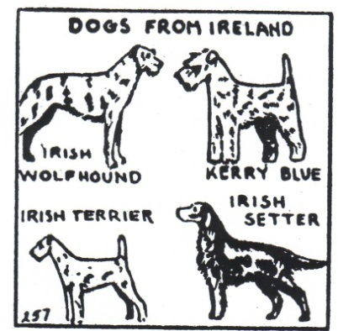

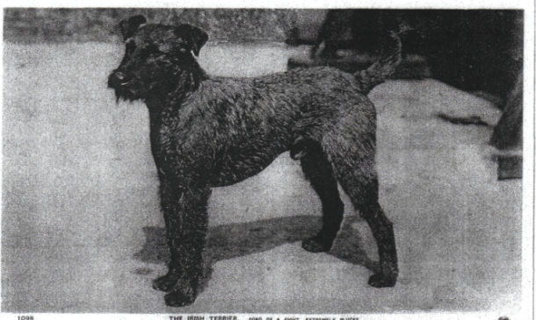

I The Dog: What makes an Irish look like an Irish terrier
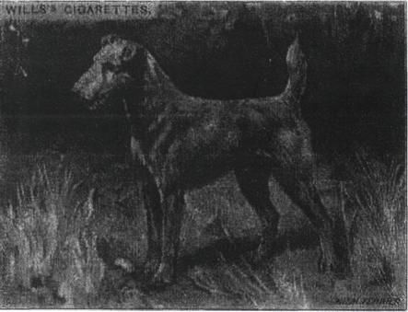
From its racy, longer cast outline to its expressive ears and eyes, the Irish terrier is a distinctive breed of dog. Here are some important features that are essential to understanding the makeup of the Irish Terrier.

Body
The Irish Terrier should have a moderately long body which comes from a longer rib cage and not a longer loin. A shorter loin anchors the spine and prevents it from bouncing up and down. A short back is not characteristic of the Irish Terrier, and is extremely objectionable. The back must be strong and straight, free from appearance of slackness or "dip" behind the shoulders. The loin should be short and muscular, and slightly arched, the ribs fairly sprung, deep rather than round, reaching to the level of the elbow. The bitch may be slightly longer than the dog. A high tail set is desirable but not higher than the withers. The body should have a graceful outline, not a short, cobby, or square appearance.

Then comes the racing outline. . .which calls for not too much width of chest, though the fox terrier front is equally wrong. . .a modified greyhound cut-up in the loin, and good length from hip to hock..." (The Dog Book 1906)

Correct and incorrect body outlines
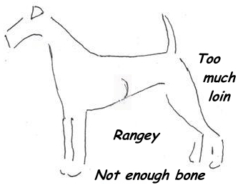
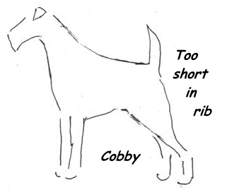
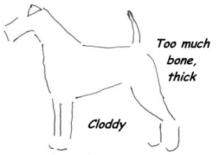
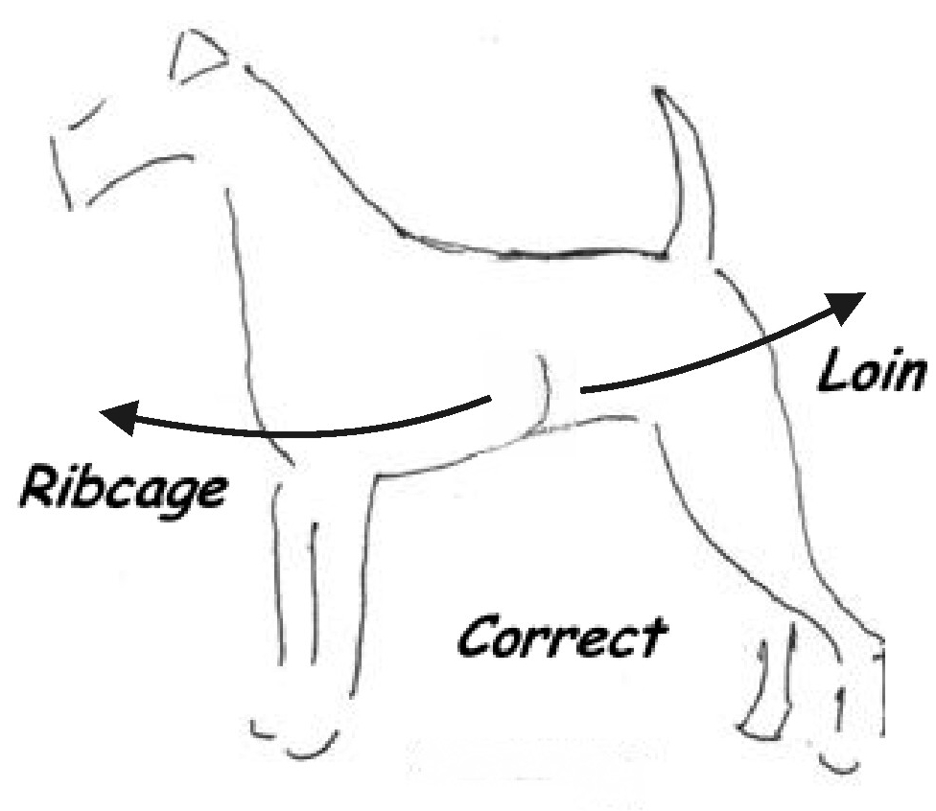

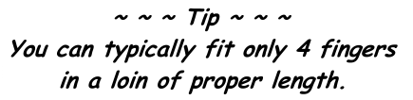

Head and Ear Carriage
  - Head
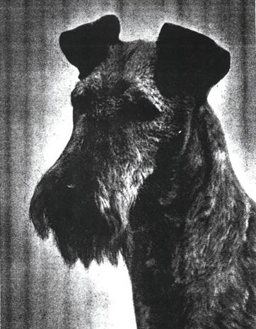
The Irish Terrier head should be in proportion to the rest of the body, the skull flat, rather narrow between the ears, narrowing slightly towards the eyes; free from wrinkle, with the stop hardly noticeable except in profile. Foreface and skull should be approximately equal length to the skull, never longer. The length of a mature, well-developed and well-balanced Irish Terrier male of correct size should average about eight inches. The foreface should be about one half inch shorter than the skull.
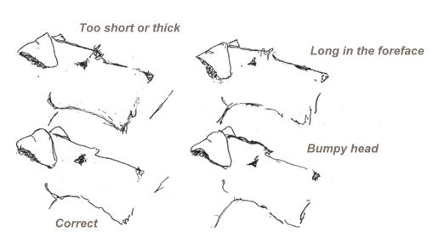
When viewed from above, the head should be slightly wedge shaped, with no appearance of falling away forward of the eye. Excessive muscular development of the cheeks, or bony development of the temples, are conditions described by the fancier as "cheeky," or "strong in head," or "thick in skull," is not desirable. The "bumpy" head is a skull which presents two bumps of bony structure above the eyes.

  - Ear Carriage
Ears are small and V-shaped; of moderate thickness, set well on the head, and dropping forward closely toward the outside corner of the eye. The top of the folded ear should be well above the level of the skull. Ears should drop forward closely to the cheek. Ears should be lifted above the head level lying closely to the head after the drop, pointing to the outside

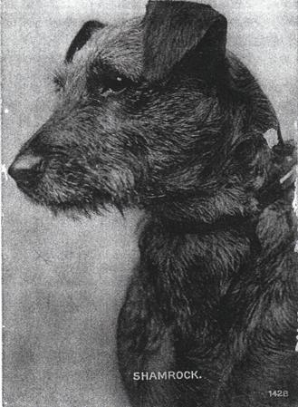
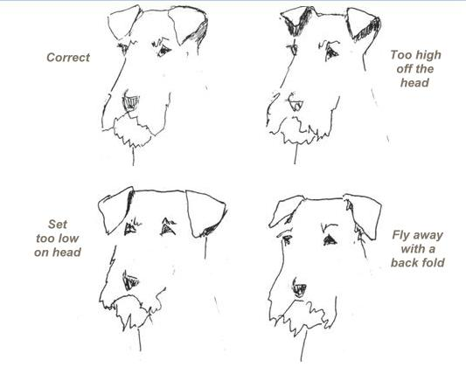
The eyes should be small, dark and expressive.

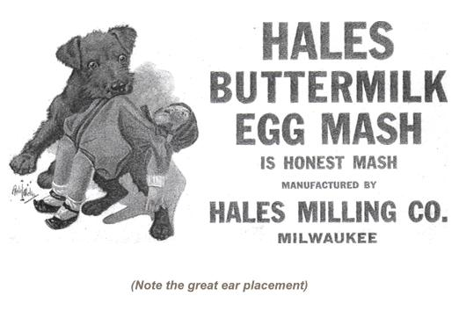

Coat and Types
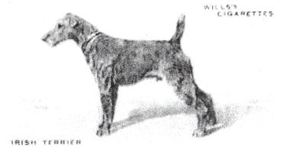
The Irish Terrier is a double coated dog.
The coat should be dense and wiry in texture, rich in quality, having a broken appearance, but still lying fairly close to the body, the hairs growing so closely and strongly together that when parted with the fingers the skin is hardly visible; free of softness or silkiness. At the base of the stiff outer coa t there should be a growth of finer, softer hair, lighter in color, termed the undercoat. Single coats which are without any undercoat, and wavy coats are undesirable; the curly and kinky coats are most objectionable. Leg and face furnishings are to be of the same texture as the body coat. A small patch of white on the chest is permissible. The dog should be whole colored.
Colors: Bright Red Red Wheaten Golden Red Wheaten

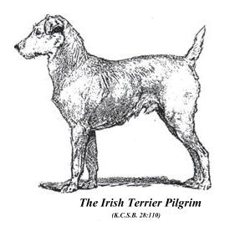
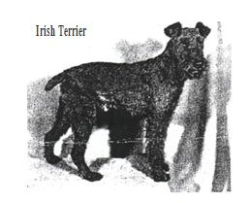

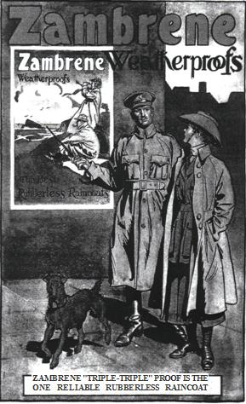
  - Types of coats
Smooth Coat - Similar to a Smooth Fox Terrier, without undercoat and face furnishings.
Flat Coat - Hard, close fitting coat; sparse undercoat. Generally head furnishings are plentiful but of poor quality and having length. The leg hair is of the face quality, but sparse.
Open Coat - Similar to a flat coat, with a lot of leg and face furnishings, especially the beard. This coat does not "hold" well and "blows" easily giving the appearance of a cat's coat.
Soft Coat - Is just that, silky and without undercoat.
Curly / Kinky Coat - Is a very hard, wiry coat that forms tight rows of curls on the back and neck. These types of coated dogs will not have leg or face furnishings and won't have an undercoat. To some old timers, they are referred to as "pick-out" coats.
Wavy Coat - Is often thought of as the correct coat but it is not. It is a good coat with a good amount of undercoat and a moderate amount of leg and face furnishings.
Broken Coat - Is the true, correct coat. It has a dense undercoat with a moderate amount of leg and face furnishings which are dense and of good texture. The coat is dense, thick, of hard texture, with "good life" and spring. As a new coat of this type grows in, it lies flat, but upon maturity it begins to take on the appearance of breaks without curls or waves.

Topline and Hindquarters
  - Topline
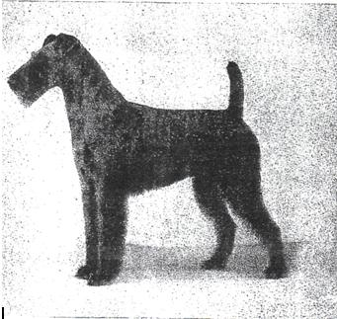
The back must be strong and straight, and free from an appearance of slackness or "dip" behind the shoulders. The loin should be short and muscular, and slightly arched.
  - Hindquarters
The hindquarters should be strong and muscular; thighs powerful; hocks near the ground; stifles moderately bent.

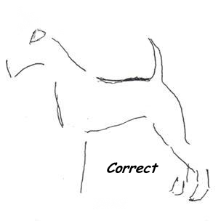
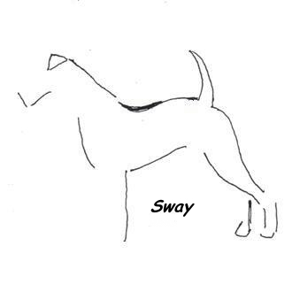
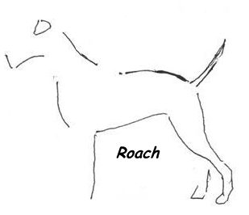
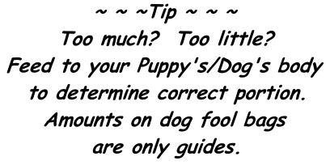

Stern or Tail

Tail, should be docked and should be set rather high but not curled. It should be of good strength and substance. A high tail set is desirable, but not higher than the withers. (Most dogs from overseas are not docked)

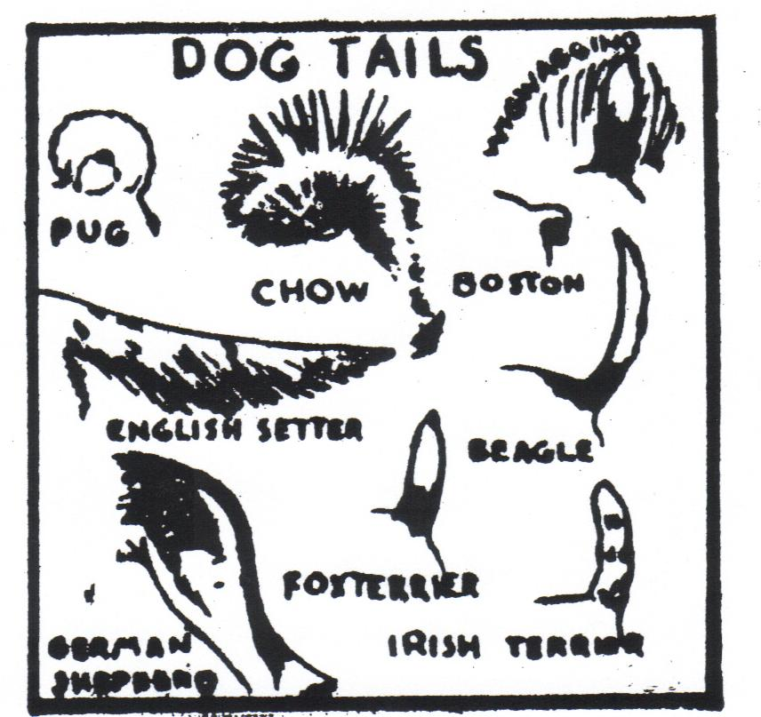
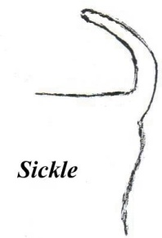
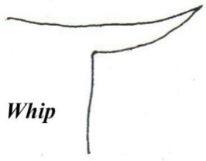
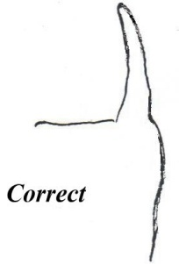
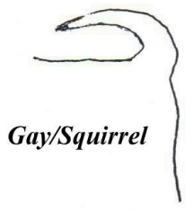

Feet

The feet should be strong, tolerably round and moderately small, "cat paw" like in shape. Nails should be dark.
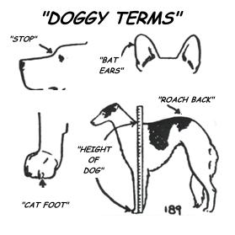
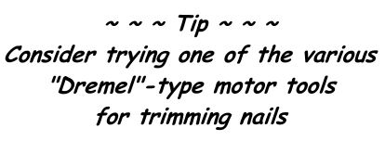
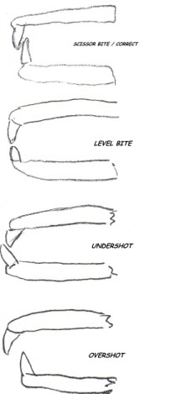
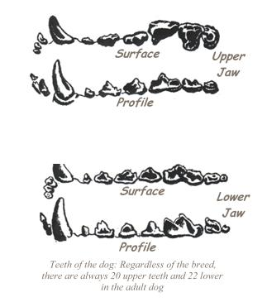

Teeth

Teeth should be strong and even, white and sound, neither overshot nor undershot.

II Basic Maintenance: How to make an Irish look like an Irish

Ear setting and proper coat care are two essential activities needed to achieve the proper look on an Irish Terrier. A variety of styles and techniques are presented here to assist you. The techniques you develop will depend on your dog’s individual requirements. His/her ear structure and coat quality will be an important factor in determining how you set ears or which grooming style you employ. The key words are patience and persistence no matter what you do. The comfort and health of your dog is also an important consideration, so we have included advice on pads, nails, teeth and other areas.

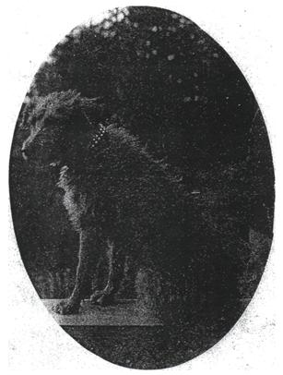

Ear Training and Gluing
Ear training is practiced to achieve a folded position of the ears when the dog is alert and carrying them at attention. The majority of pups will have their ears trained by gluing. Gluing begins around six to twelve weeks of age and until the teething period ends around seven to eight months. Some breeders will wait until the fourth month before beginning to glue. The objective is to create good ear carriage by creating a lift to the ear and a good tight fold. Gluing consists of applying glue to the underside of the ear and either attaching it to the skull or folding it against itself. When gluing, always leave some open space to allow for air to ventilate the ear canal.

* Apply Tincture of Benzoine to area of ears and head to be glued. This creates a barrier between the skin and glue.
* Glue hair to hair only.
* Do not re-glue if ears are starting to hold "...don't fix if it ain't broken."
* Re-glue when ears begin to fall or need adjustments.
* Always check for infections, smell ears for any sour, unpleasant odor. If an odor is apparent, free infected ear and treat area with antibacterial ointment.
* Re-glue when area is healed and hair has re-grown.
* Attempt to keep ears glued at least fourteen consecutive days, and then assess.
* Success is achieved with consistency and persistency.
* Clean off old glue by applying baby oil or Avon's Skin So Soft. Comb clean with a flea comb.
* Watch for any LATEX REACTION.

  - Ear training equipment
* Tincture of Benzoine or New Skin
* Ear glue (fabric adhesive Tear Mender or Duo Surgical Adhesive).
* Cotton balls
* Styrofoam plate (to pour a quantity of glue)
* Baby Oil or Avon's Skin So Soft.
* Flea comb
* Antibacterial ointment
* And last but not least—persistence

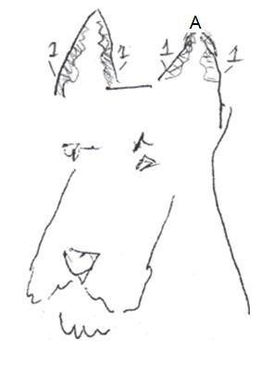
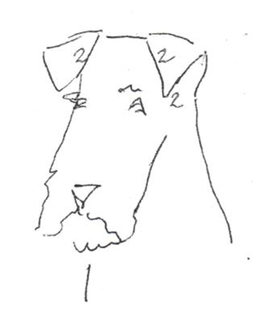
Variations on ear gluing

1. Apply glue on the inside of ears (ears are standing straight up for illustrative purposes). Wait a few minutes until the glue becomes tacky.

2. Place tip of ears pointing to the outside edge of the eyes, (gluing ears against each other)

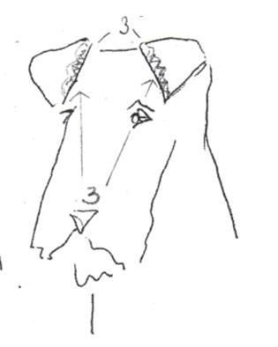

3. Apply more glue on the inside edge of each ear between the inside fold and the head, and down the inside flap but not to the tip. Press firmly against the head until secure.

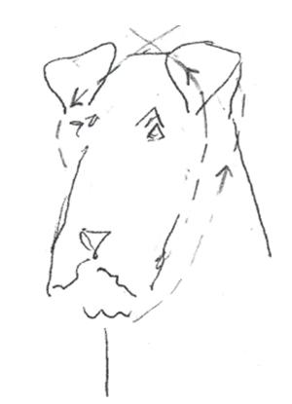

4. Adhesive tape or masking tape can be applied until glue is thoroughly dry. Start the tape under the chin, come behind one ear and across the other, go back around reversing the process. Leave the tape on overnight, then remove.

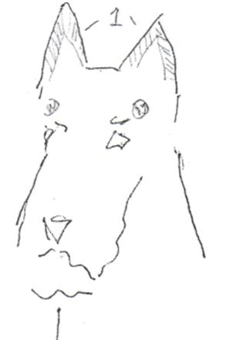
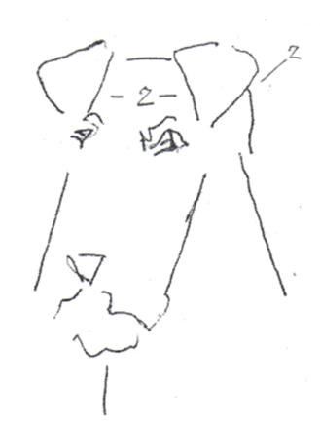
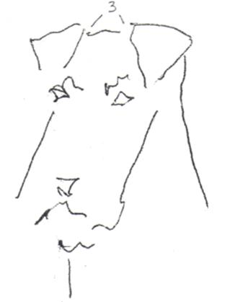
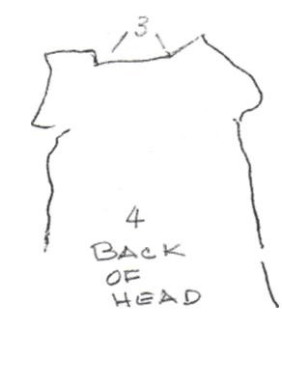
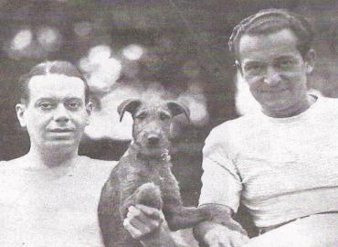

1. Apply glue on the inside of the ear. Apply a drop of glue to the outside edge of the eye.

2. Attach ears to the top of the head placing the ears flat against the skull. Place the tip of the ear to the outside edge of the eye. Leave the outer fold open for air.

3. Place glue inside the back "pockets" of the ears and glue the ears flat to the skull.

4. This helps create the ear lift, (see view of back of head to locate "pockets")

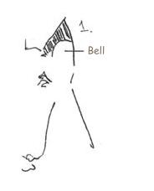
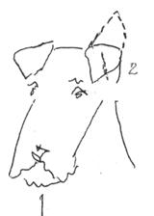
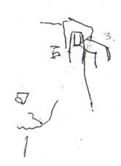
1. Apply glue in shaded area of ears.
2. Fold ear over with the idea of creating a crease in the ear in the process of gluing.
3. Insert finger tip into dog's ear to create a roll. Pinch outer edge with thumb. Roll to create a "crease" in the center of the ear.
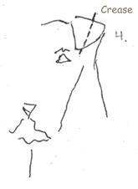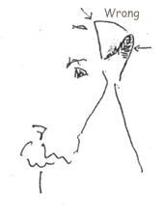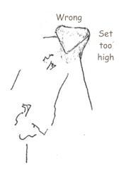
4. Crease position. Glue back "pocket" flat to the skull. Make sure there is a crease running on a SLIGHT vertical angle.
5. Ear has been glued too far over the edge.
6. Ear has been glued with the tip of the ear glued too high on the skull.

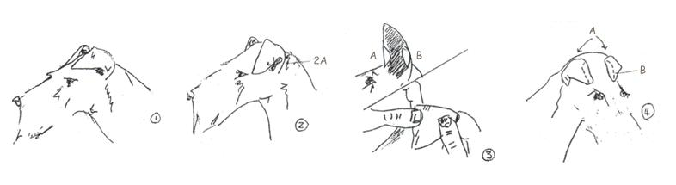

From the ITCA Breed Book
l. To assist the lift at the point where the top of the ear joins the skull, many breeders set the ears high on the skull towards the middle of the head. Sometimes this technique flattens the "bell" of the ear (2A), causing the outer portion of the ear to stand out or, in several cases, to curl back over itself into a rose ear. (#1: ears set high on skull to create lift)

2. To correct this tendency and create a tight fold which brings the tip of the ear down against the head, the ear is often reset with the tip glued very close to the base of the ear. These methods are often used alternately. (#2: the tips of the ears glued close to the base creates a crease across the ear and gives proper curvature the "bell"(2A)

3. Some breeders prefer to apply glue to the inside of the top fold (#3A/B) and the inside of the bell. These areas are then pressed together to create a sharp fold at the top of the ear and give proper shape to the bell (2A). Glue is applied to the exterior of the top fold and to the inner edge of the ear. The fold is glued to the back of the skull and the top edge of the skull behind the brow.(#3: place glue on the inside of the top fold(3A) and inside bell(3B), then press together).

4. Glue the exterior of the top fold to the back of the head (#4A), and the top edge of the skull behind the brow (4B).

Grooming: Terms and Illustrations

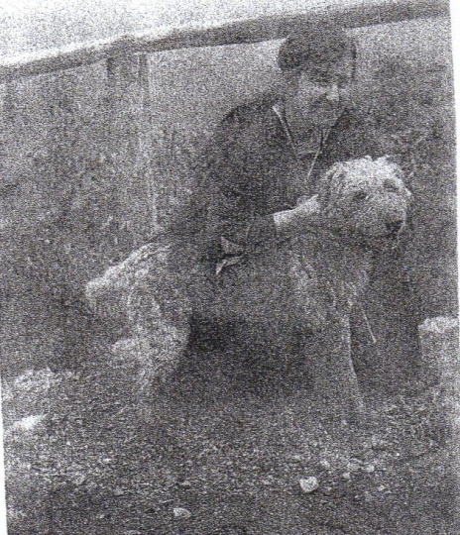
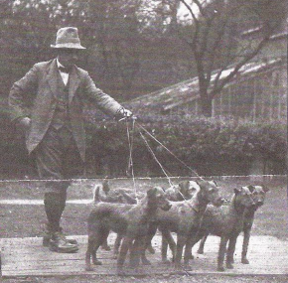
A groomed Irish is a thing of beauty
(and a cleaner house)

  - Grooming Terms
plucking - using fingers to remove hair like feathers from a dead chicken.
stripping - using some sort of serrated blade to remove hair (e.g., hacksaw blade or half of thinning shears) by combing and pulling the hair with one's thumb. Commercially made stripping knives are available.
carding / raking - combing or brushing through the coat with a stripping blade, a looped shedding blade, or even a hacksaw blade to remove excess hair or excess undercoat. (Carding and rolling coupled with brushing will produce the most desirable coat.)
rolling - using fingers to remove small amounts of dead hair as new hair comes in. It creates a staggered growth.
brushing - using a terrier palm brush or even something like a small sisal scrub brush of natural bristles, will remove dead hair untidy undercoat, and put a "polish" on the Irish jacket.
clippering — using an electric blade to maintain the coat. It should be noted that repeated clippering will reduce the hard jacket to one that most resembles that of a Soft Coated Wheaten. Clippering is highly recommended for the maintenance of the "pick-out" or "kinky" coated animal or the aged Irish that no longer has the patience for regular stripping.

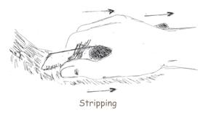
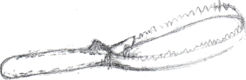
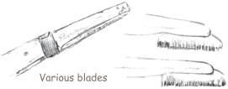
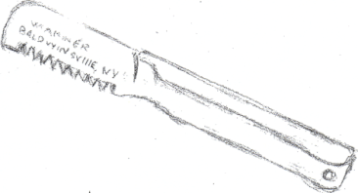

Basic Stripping
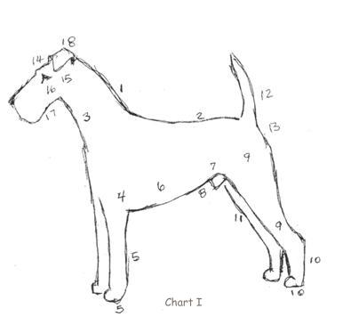
This illustration provides basic instruction on pet stripping without any regard to staging (creating staggered growth of coat).

1. Trim neck very closely and evenly into back.
2. Trim back evenly but not as closely as the neck.
3. Front part of neck and brisket to be trimmed closely, with just a shade more hair left on as one works down to where the front legs join the body.
4. The front shoulders to be trimmed evenly and closely.
5. Front legs should be slightly trimmed to straighten lines. Trim principally on back line; trim superfluous hair from edges of feet and between toes, shaping to roundness.
6. Shape ribs to follow body confirmation from a finely trimmed back to a fuller coat on the underpart of the ribs and the chest; do not leave any on sides or under chest that are in any way shaggy.
7. Trim loin but do not emphasize tuck-up.
8. Trim only shaggy and snarled hair from belly.
9. Trim thighs from back line to hock, taking off sufficient hair to show a definite outline of leg.
10. Straighten back line of hock and trim superfluous hair from edges of feet and between toes; shape to roundness.
11. Trim inside of hind legs down to hock joint.
12. Trim tail evenly, but not too closely, to a tip towards the head.
13. Trim stern closely and evenly.
14. Trim skull very closely. Leave eyebrows but not too heavy. Leave slightly more hair over inside corner of eye than outside corner.
15. Trim cheeks back from corner of mouth to ears.
16. Trim under eyes to emphasize expression.
17. Clean under jaw from corner of mouth back to neck. Leave chin whiskers and brush forward.
18. Clean off ears inside and out, straighten edges with fingers.

Staged Stripping
This illustration provides instruction with specific consideration to tuning, or staging the coat. Staging; removing sections of the coat at certain time intervals, takes into account areas that grow in more quickly. This technique allows for a more finished outline.
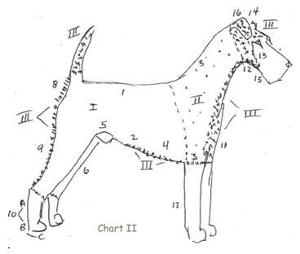

I. Strip First
II. Strip one week to ten days after "I" (as long as fourteen days)
III. Strip one week after "II" or two weeks before a show.

1. Strip from withers to tail closely and evenly.
2. Shape the rib cage to follow body confirmation, leave slightly fuller coat on underpart of ribs and chest.
3. Strip hair very closely and evenly, do not leave a hole where shoulders join legs.
4. Pluck shaggy or snarled hair from belly and even hair length. Clipper from belly button to genitals. Clipper penis and testicles.
5. Pluck loin but do not emphasize tuck-up.
6. Trim sides of hind legs down to hock with fingers. Shape to a "soft" outline.
7. Strip tail evenly; though not too closely, to a tip. It should look like a carrot.
8. Strip stern evenly and closely.
9. Strip thighs from back line to hock, taking off enough to show definite outline.

10. Complete the next three steps:
* Straighten back line with a stripping knife.
* Cut with scissors excess hair between toes but so not create "grooves" between toes. Trim feet to cat-paw shape.
* Cut nails (using grinder or nail cutters). Round with file. Nails must not touch flat surface when dog is standing. Dog's nails must never be allowed to grow so long that they curl. If dog has dew claws, they too must be cut.
11. Strip front of neck and brisket closely; leave a shade more hair where front legs join body, taper hair to an inverted "V" shape.
12. Strip cheeks from corner of mouth back to neckline.
13. Strip from corner of eye to corner of mouth back to cheeks. Leave a small amount of hair (a wedge) just under lid to create the "fiery Irish" expression. Try not to hollow out the muzzle by creating a "dished out" effect (from removing too much muzzle hair).
14. Strip skull closely, even off the length of eyebrow hair; leave slightly more hair to the inside corner of the eye, creating a wedge. (Do not leave a hole or dip behind where the skull and neck connect.)
15. Strip or pluck under jaw from corners of the mouth back to the neck; leave chin and beard hair; brush hair forward and shape by plucking hair in a twist-like motion into a box shape.
16. Strip or pluck ears inside and out; straighten edges with fingers (not scissors). Ear tip should come to a rounded point. Pluck long hairs from ear canal.
17. Shape hair on front legs to a cylinder-like shape (paper towel roll). Create uniformity by plucking or stripping lightly; pluck hair on back of front legs to straighten line, but maintaining the cylinder shape. Clean elbows of hair.
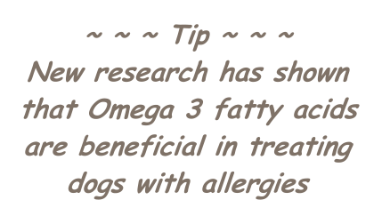

Show Grooming
These diagrams build on chart "II" which presents more detailed information on the frontal and rear profiles of the dog. The combination of charts "II" and "III" provide a good foundation for show grooming.

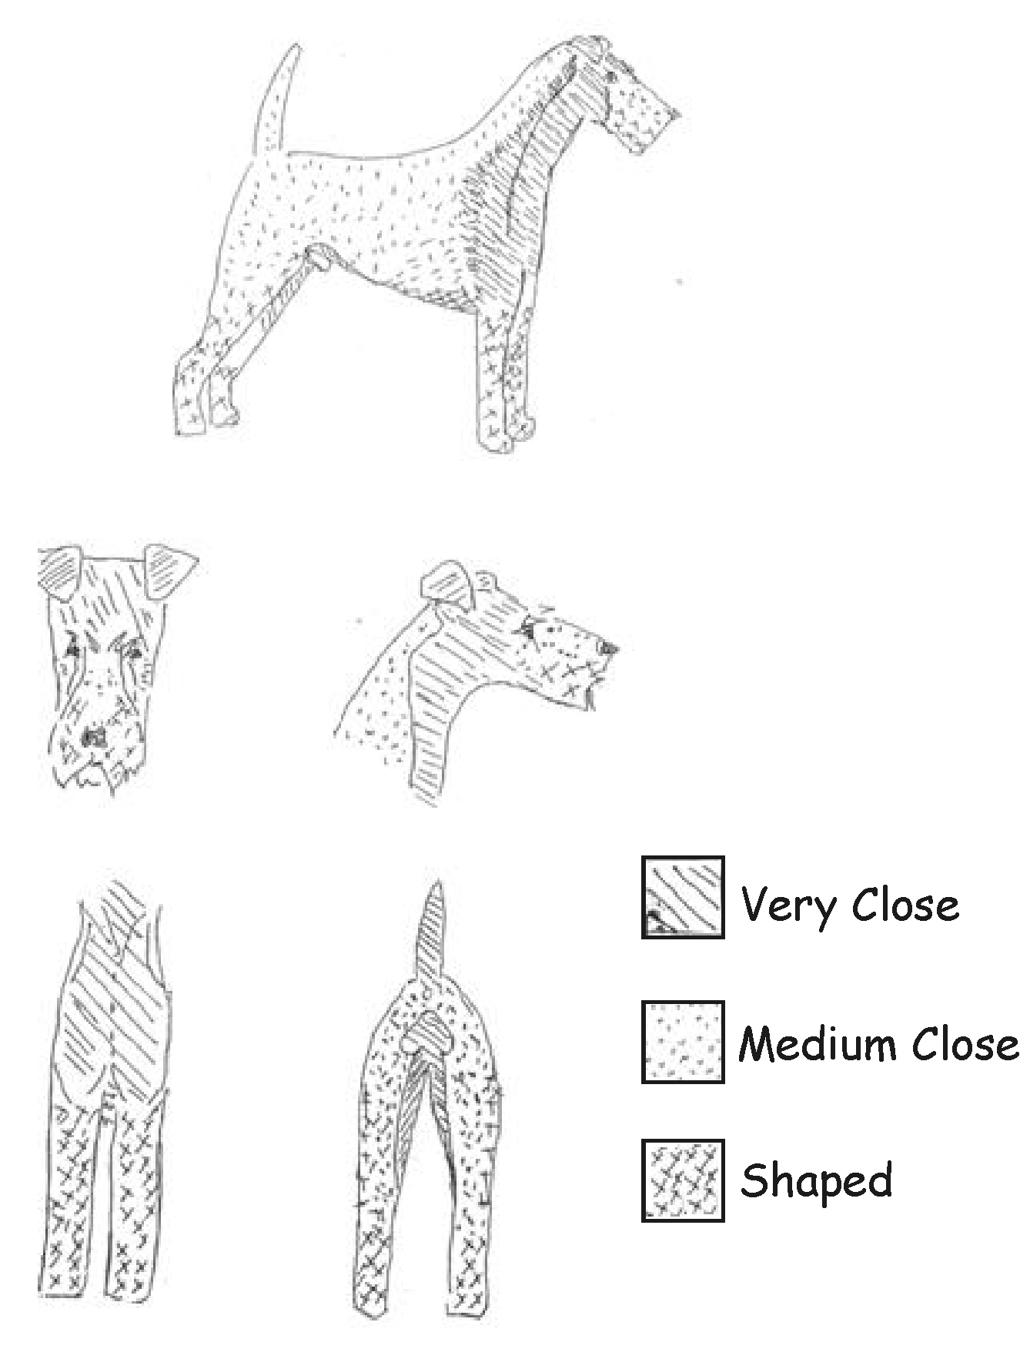
Chart III

Pet Clippering
The main idea behind clippering is to provide an easy method of maintaining the Irish Terrier jacket especially for the older dog or due to the condition of the coat. This clippering pattern maintains the general look of the breed. Repeated clippering will soften and lighten the dog's coat.

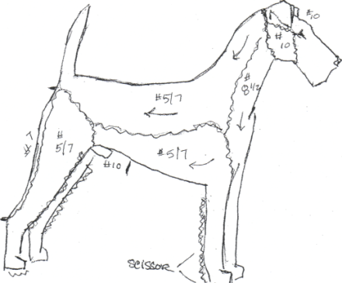

Using electric clippers, Blade #5, #7, #81/2, #10, and a pair of scissors.
#10 - Ears, head; corner of eye to corner of mouth.
#81/2- Neck and chest, to ridge on neck.
#1 - (thick coat) base of skull to back; to tail.
#5 - (thinner coat) base of skull to back; to tail.
#5 / #7 - Shoulders (depending upon coat).
#5 / #7 - Sides
#7 - Back of hind legs (hock to buttocks).
#10 - Between pads of feet; gentiles. Scissor around anus, around feet and legs, (brush out furnishings and scissor to shape.

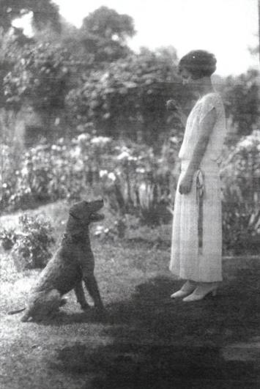

Care of Kinky Coat
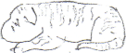
Kinky Coats - A kinky coat is described as an extremely hard wiry coat devoid of undercoat and lacking furnishings. This "pick-out" coat has been described as being dark red in color although lighter versions do exist. The old time kennels kept a kinky coated dog or bitch available for breeding to add texture to softer coated mates. This practice is not suggested in today's standards. Because of the extreme texture of this type of coat, clippering is the best method of maintenance. Borderline kinky coats have been known to be maintained by simple daily brushings.
At birth a kinky pup's coat will appear to have a crimped wave resembling a Persian lamb's coat. This wave is noticeable on the head, down the face, and onto the body. A more extreme specimen will have a distinctively wavy head which continues between the eyes, down the neck, and onto the shoulders. As implied, there are degrees of these types of coats. Around four to eight weeks of age, the coat may appear relatively smooth, but this is only a temporary appearance. The kink will begin to reappear around eight to ten weeks of age. As the puppy matures, its coat will take on a dull / dry appearance, breaking easily, especially when rubbed; and will come out very easily if plucked. At this same stage, the coat appears very sparse and transparent. The eyes and bridge of the nose will appear "moth eaten" and sometimes the eyes have a "weepy" discharge. As adults, these coated dogs can be oily and have an odor.
Antioxidant supplements have been known to help maintain this coat and give it life. A low fat diet is suggested. Clippering the coat starting at around five to six months of age is recommended. Clipper often to prevent the coat from getting to long.
Clippering Directions
* Brush out the dog and wash with a mild liquid soap (Ivory liquid or Suave Shampoo).
* Cream rinse only on occasion (because conditioners attract dirt).
* Dry dog.
* Clipper with #5 and #7 blades (see clippering chart).
* Note: it takes several clipperings to soften the coat.

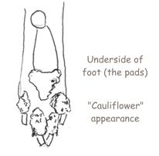
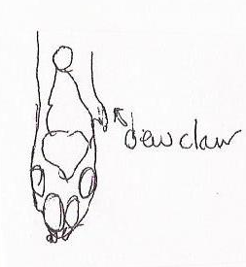
Cracked Pads
Cracked Pads - There are certain conditions such as excessive heat and dryness that can lead to cracked and horny pads. Should this occur, gently trim loosened horn and edges with scissors. Take care not to cut into live tissue. A thorough massage of the effected pads each day with either olive oil or borate of glycerin should improve this condition. Until the dog heals, it should be exercised on softer surfaces.

Nails

  - Nail trimming
Cutting nails on an Irish can be challenging. The best philosophy is early and often. Start the dog at an early age to get it used to having the nails trimmed. Start by cutting the tips of the nails often; at least twice a week. Use an emery board to round the rough edges, smooth the nail and bring back the quick. Rewarding the dog with treats helps the process. Nails should be kept short to maintain structural soundness. Long nails stretch tendons and ligaments out of shape and these cannot be repaired. In this condition, the dog does not have physical endurance and is then described as being “down on its pasterns”.

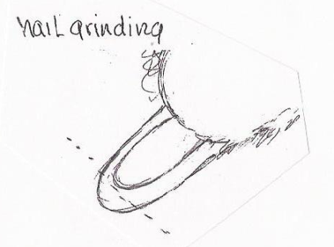
Nail grinding – If nail grinding is preferred in maintaining your dog’s nails, again begin at an early age. Sandpaper cylinders attached to a grinder tend to be best because they don’t heat up like stone discs. Grinding should be done like a Ferrier does a horse’s hoof, from the underside. Remove the length of the nail with a straight line and round off the edges. Remember, just like a Ferrier works the hoof of a horse by lifting the leg and working from the back, so too with your dog’s nails. Don’t forget the treats!

Teeth
  - Brushing
Irish Terriers tend to develop tartar at around age three. A practical way to maintain your dog's teeth and help prevent tartar buildup is to regularly clean his teeth starting at around the age of two. Take a wash cloth moistened in salt water and gently brush the teeth and gums. Today there are many commercial products available to aid you in brushing your dog's teeth. Many of them include tooth brushes, meat flavored tooth paste and many other aids such as dental rinses and sprays.

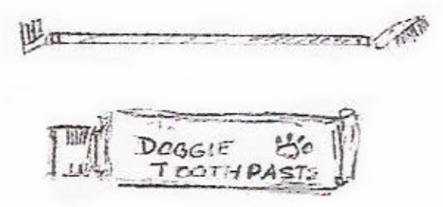

  - Scaling
Scaling a dogs teeth with dental instruments is another option for dental maintenance but is not for everyone. Guidance from someone with this experience is strongly recommended. Dentist like tools are used to chip, scale, or remove accumulated tartar. A steady hand and nerves are needed for this procedure. Following this method, gums and teeth should be cleaned well with a wash cloth moistened with mouth wash. This helps to rinse the mouth and prevent infection. Scaling tools are available through pet supply catalogues.

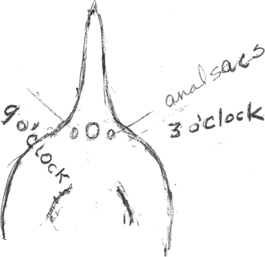
Anal Sacs
Anal Glands / Sacs - are located under the skin on either side of the anus at around three and nine o'clock just under the base of the tail. When full, the dog has an unpleasant odor about him which may remind one of dead fish. The dog may attempt to relieve the pressure and express the fluid by scooting across the floor, rug or other ground surface. To remedy this condition and to help prevent clogged anal glands, the contents can be expressed using a damp paper towel. Holding the tail up with the left hand and with the thumb and middle finger of the right hand place the paper towel on either side of the anus (at three and nine o'clock). Then apply pressure in these positions by bringing the fingers together in a pinching motion. The secretion should range from a creamy to dark brown color with its characteristic odor. Anything unusual like blood or puss should be brought to the attention of a vet. The frequency of anal gland expression can depend on the age of the dog and its breeding. Younger animals seem to need attention more often that adults and seniors. Some dogs will naturally express themselves when they are excited (e.g. when confronting another dog or even riding in the car).

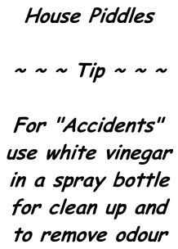
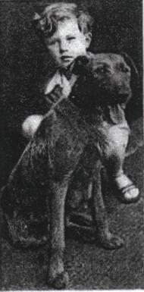

Stool Eating
Most dogs find stool from other creatures quite appealing. With maturity and a balanced diet this attraction tends to dissipate. But the Irish are well known for eating their own or that of other canines with which they share space.
To alter this habit, try the following:
* Never clean up messes in front of your canine. He will think that's the thing to do.
* Don't correct your dog when he shows interest in his stool. The more you correct the quicker he'll consume. Trust me on this one!
* When Fido shows interest in recycling, redirect his focus..."Where's the squirrel?!"
* Consider adding canned pumpkin or frozen green beans to his meal to add fiber and perhaps an unpleasant taste to the stool.
* Once your dog eliminates, spray the pile with something like vinegar or "Bitterapple."
* And if all else fails, scoop as soon as he poops.

III Dog Behavior: What makes an Irish act like an Irish
The standard says an Irish Terrier should be” …of good temper, most affectionate and absolutely loyal to mankind. His life is one of continuous and eager offering of loyal and faithful companionship and devotion. He is ever on guard, and stands between his home and all that threatens.”

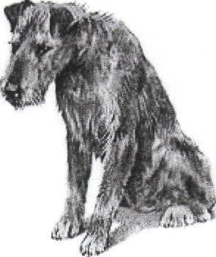
Basic Laws of Learning / Basic Laws of Training
~ ~ ~ Tip ~ ~ ~
Every dog claims the wolf as its ancestor.
Understanding wolf behavior will help you understand and train your dog.
  - Basic laws of learning
* Behavior that is positively reinforced will become stronger and more frequent.
* Behavior that is not rewarded will become less frequent and tend to disappear.
  - Basic laws of training
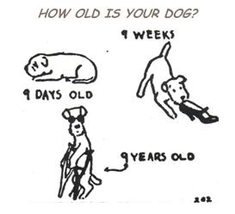
* Reward acceptable behavior with praise, treats of clicking.
* Ignore, prevent or neutrally interrupt or reprimand undesirable behavior.
* Teach the dog to stop doing something he would do on his own but you find undesirable

~ ~ ~ Tip ~ ~ ~
Must Read Publications:

PUPPIES FOR DUMMIES
2nd edition by Sarah Hodgson
DOG TRAINING FOR DUMMIES
2nd edition by
Jack Volhard & Wendy Volhard

Developmental Levels and Training

  - Under 8 weeks
* Pack oriented
* Doesn’t do well being isolated for long periods of time.
* Responsive to "leader" for directions, "other" oriented.
* Needs early socialization for a healthy, secure personality.
* Needs to meet other dogs in non threatening circumstances.
* Needs lots of sleep.
* Introduction to crate training is important
* Human begins to substitute the dam as pack leader.
*
~ ~ ~ Tip ~ ~ ~
Temperament testing at 7 weeks
will help predict future behaviors
See: Volhard Puppy Aptitude Test
www.volhard.com/puppy/pat.html

  - 8 to 12 weeks
* Becomes independent of litter
* Ready to bond with human pack.
* Becoming more physically coordinated.
* Has improved bladder control.
* Curious with a short attention span, easily distracted.
* Uses mouth to explore, an increased urge to chew, teething will begin.
* Providing safe chew items is important.
* Between seven to nine weeks may become cautious of anything new in his environment.
* Still needs lots of sleep
* More serious crate training should begin.
* Human leader establishing his role.
* Fear imprinting period; avoid exposing the pup to traumatic experiences. Again, needs to meet other dogs in non threatening circumstances.

  - 12 to 16 weeks
* Better developed senses and motor skills
* Understands some basic commands using clicker and or food as a reward.
* Bladder and bowel control still improving.
* Teething becoming evident.
* Immune system mature
* Inquisitive and exploratory
* Four months is a marker for human and animal socialization. Good experiences are important. Provide puppy playtime.
* Establishing tolerance for grooming routines is important. Placing puppy on a grooming table for short periods of time, brushing, light stripping; playing with the feet and ears
* Lead breaking should begin, buckled collar, choke chain; head halter.
* Puppy classes.

  - 4 to 6 months
* Major physical growth period
* Teething is in full effect, causing puppy's ears to "go off." Ear training is a must during this time.
* About four months, puppy will experience avoidance period and can be hesitant about doing new things.
* Providing more socialization with a wide variety of people, animals, places, sounds, and sights is important. Take them places; shopping center parking lots, pet supply stores; puppy classes
* Continued reinforcement of grooming habits, lead training, and toilet habits is important. Most important that by 6 months the puppy should be able to stand on a grooming table with confidence and tolerate light stripping
* Humans should be establishing a leadership role with positive reinforcement and changing undesirable behaviors.
* Intermediate puppy classes.

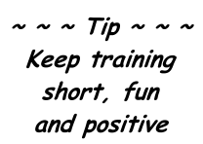

  - Juvenile (6 to 18 months)
* Puppy begins to act more like an Irish Terrier
* Sexual maturity is reached
* More physically mature
* Teething and ear set completed
* Can become less tolerant of dogs of the same sex
* Most breeders recommend neutering and spaying at this time
* Can become more single minded, destructive, revengeful; challenge authority.
* Greater exercise needed to channel energy level
* Advanced obedience classes, clicker training
* Should know basic obedience (come, sit, stay, down, heal).
* Should be lead broken, crate trained; tolerant of grooming.
* Human has established leadership role with positive reinforcement changing undesirable behaviors.
* Consider advanced obedience class and clicker training.

~ ~ ~ Tip ~ ~ ~
Don’t forget to license your pet!

NOTE: Retractable leads can lead to what can be described as a "thick neck." However, they are great tools for distance training or recall but are not good for causal walks in the park; Fido will quickly learn he's in control!
ALERT: Holding on to the retractable cord and not the handle can lead to injury!

~ ~ ~ Tip ~ ~ ~
Baby gates that block access to
rooms will help keep your Irish
contained and out of mischief

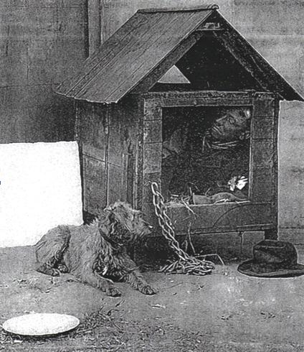
Crate Training
Using the established fact that the domestic dog claims the wolf as its ancestor, the use of a crate or "den" is a natural progression in training. A crate is not a prison to your dog.
* Dogs feel secure in close quarters
* Crating a puppy at intervals throughout the day is the best way for housebreaking. Dogs try not to soil in their space.
* Cover the crate to create a more "den like" space.
* Use the crate for feeding, sleeping, and "time out."
* Use a crate when the dog is unattended.
* Buy a large enough crate so that when the puppy is full grown it is large enough to stand up, lie down, and turn around.
* When the crate is too big for the puppy, section it off into a smaller portion and enlarge the space as needed.
* Plastic, airline crates are more den-like, more portable and easier to clean. They can be used for the car or on the airlines.
* Wire crates allow for better air flow and provide a better view of home activities.
* Remember, a puppy, young dog, or adult will need numerous breaks from his crate. Toilet time, play time, feeding and watering opportunities should make up his daily schedule.
* Remember, a crate is not a means of total confinement. Dogs are social creatures and can suffer from isolation.

Correctable Personalities
  - Reactive / Aggressive Dogs
* Displays threatening behavior towards humans and other dogs including growling, teeth bearing, and biting
* May display possessive behavior with respect to its food
* Can become more evident as dog reaches adulthood
* The more the dog gets to repeat aggressive displays, the more reflexive and entrenched the behavior becomes
* Do not let the dog practice this behavior
* Prevent, neutrally interrupt, "alter" emotional state of this behavior
* Consult a dog trainer or behaviorist to help modify this behavior
  - Dominant Dogs
* Usually a status related issue in a multiple dog household
* " Social climbers who want to get to the "top"
* Obedience structuring - prevent, neutrally interrupt, or reprimand (remove the "status")
  - Submissive / Needy Dogs
* Confidence issue, dog is unsure of itself
* Over disciplining can worsen the issue
* Do not over-indulge or confront, and avoid direct stares
* Use a calm, relaxed demeanor
* Build confidence by using positive reinforcement for desired behavior
* Ignore or prevent undesirable behavior
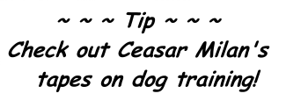

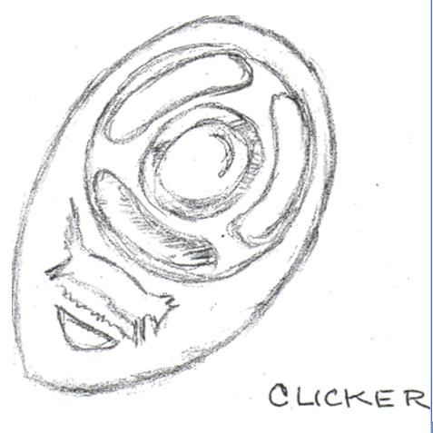
Clicker Training
A clicker is a small hand held device that clicks when squeezed between thumb and forefinger. It provides an auditory cue to let dog know he has done something correctly and will be rewarded with a treat. It is a form of positive reinforcement in dog training.
Clicking with your Dog – Peggy Tillman
(Comprehensive fun tricks)

Click to Win – Karen Pryor
(Clicker Training for the Show Ring)

Click to Calm – Emma Parson
(Healing the Aggressive Dog)

Clicker Training on the Web:
www.aboutdogtraining.com

Special Training: AKC sponsored activities
If you want to add a special dimension to your lifelong commitment to your Irish Terrier, consider one of the following activities sponsored by the American Kennel Club. Irish are beautiful and highly intelligent dogs and are known to succeed very well in all of them. Visit www.akc.org for more information.

Companion Animal
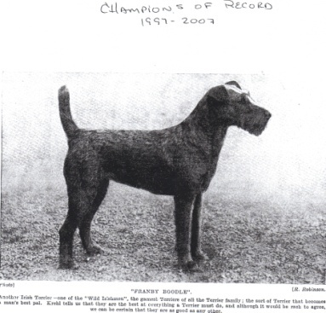
Canine Good Citizen (C.G.C.) - AKC offers C.G.C. certification which is a test for good manners. It is the first step in training a dog. Relaxed atmosphere and a requirement to perform simple everyday tasks is the basis for this certification. Dogs should remain calm in different situations and know how to behave in a crowd.
Therapy Dog - Training builds on AKC canine C.G.C. test plus a few more exercises. The purpose is to provide comfort and companionship in various situations (e.g. hospitals, nursing homes, schools). Therapy Dogs International Inc. and Delta Society evaluate and provide information for Therapy Dog Teams.

Competitive Activities
Rally - This is the link between C.G.C. programs and other competitions such as obedience, agility, or tracking. It is meant to be fun; scoring is less stringent than traditional obedience. Handler and dog perform more complex exercises than C.G.C. Working as a team, the handler is able to provide encouragement to the dog while it is performing tasks.

Obedience - These trails tests a dog's ability and accuracy when performing specific exercises in a predetermined order. The dog must demonstrate he can behave in many situations and in the presence of other dogs. There are three classes of training: Novice, Open, and Utility. At each level, the difficulty of exercises increases. Higher levels test include jumping, retrieving, scent work, and recognition of hand signals.

Agility - This activity is meant to train and condition dogs. Dog and handler teams complete the exercises of courses designed by agility judges. The tasks include jumping over bars and through tires, running through chutes and tunnels, and weaving through poles. The dog must demonstrate a safe performance by placing at least one paw in the "contact obstacles." Obstacles can include an "A" frame, teeter and dog walk. Trials consist of two courses; Jumpers, with jumps, tunnels and weave poles, and the standard course which consists of the Jumpers plus contact obstacles.
Levels of Agility: Novice, Open, and Excellent.
Objective: progression through levels with increasing accuracy and faster times.

Tracking - This activity tests the dog's ability to scent and follow a path laid by humans. The dog does not follow a handler's commands but works with his natural senses. The dog works in a harness with a long lead attached while the handler follows behind. Levels: Tracking Dog, Tracking Dog Excellent; Variable Surface Tracking.

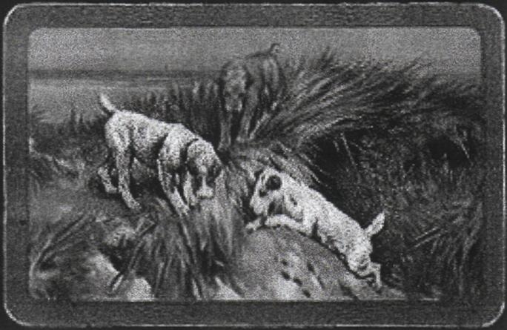
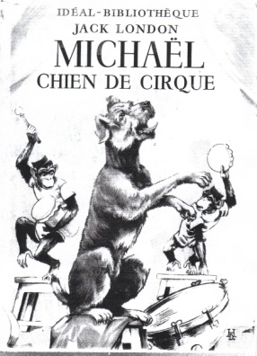

Show Competition
Conformation – The AKC offers certificates of championship title for dogs that compete in AKC sanctioned shows. Dogs are judged against their breed standard. Championship title is awarded to those dogs that accumulate fifteen points or more in breed competition. Dogs compete in a hierarchical fashion where winners at the lower levels are gradually combined to narrow the winners until final rounds arrive at Best of Breed, Best in Group, and Best in Show. Each breed is divided by sex and sometimes age. Male dogs are judges before females.
